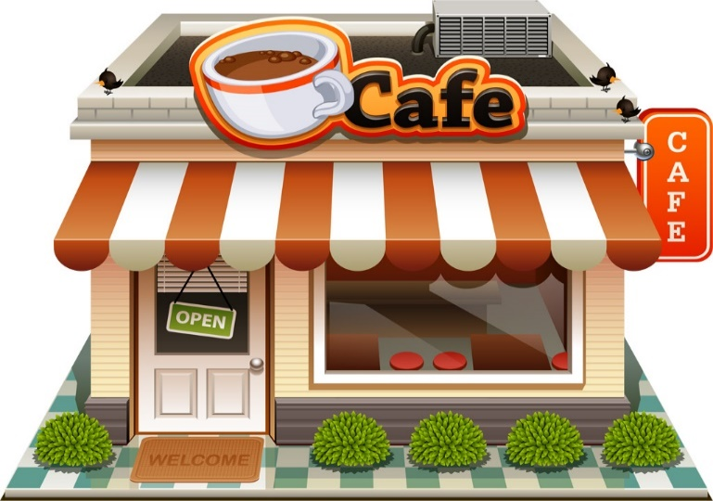Restaurants
Pizza Ranch of Clarion
102 South Main Street, Clarion, IA 50525
(515) 532-3215
La Tienda Mexicana
116 South Main Street, Clarion, IA 50525
(515) 532-2222
Casa Del Taco
115 S. Main St., Clarion, IA 50525
515-602-6166

Chappy's On Main
122 South Main Street, Clarion, IA 50525
(515) 532-2727
Grounded (closed Saturday)
118 North Main Street, Clarion, IA 50525
(515) 602-6212
Mon-Fri 7 am – 2 pm
Fuel Coal Fired Pizza
223 North Main St., Clarion, IA 50525
(515) 532-3835
Sam's Chinese Kitchen
104 Central Avenue East, Clarion, IA 50525
(515) 532-2989
Casey’s Pizza, Subs & More
222 Central Ave, Clarion, IA
515-532-3030

Subway
316 Central Avenue West, Clarion, IA 50525
(515) 532-6917

Hardees
329 Central Ave. West, Clarion, IA 50525

Wildwood Café
Located at Iowa Specialty Hosp.
1316 So. Main St, Clarion, IA 50525

El Jalapeno Mexican Store & Grill
902 Central Ave. E. Clarion, IA 50525
(515)532-2933

The Main Scoop
(ice cream & baked goods)
106 S. Main, Clarion, IA 50525

Riveter Nutrition
(protein shakes, coffees, healthy teas)
106 8th St., SW, Clarion, IA 50525
(515) 851-7159
Mon-Fri 7 am-1 pm; Sat 9 am – 1 pm

Groceries
Brothers Market
325 Central Avenue West
Clarion, IA 50525
(515) 532-2829

Granny’s Iowa Market
202 North Main Street, Clarion, IA 50525
(515) 532-2788

